***Name : HIMANSHU DIXIT***

***Enrollment Number: B64178***

***Batch: B10***

***Experiment No : 2***

***(NEWTON’S RINGS-REFRACTIVE INDEX OF LIQUID)***

***Aim:***

***1.*** *To revise the concept of interference of light waves in general and thin-film in particular.*

***2.*** *To set up and observe Newton’s rings.*

***3.*** *Find the refractive index of given liquid.*

***Formula Used:***

1. *The wavelength of monochromatic light can be determined as, =(D2m+p- D2m)/4pR  
   Where,  Dm+pis the diameter of the (m+p)th dark ring   
    Dm is the diameter of the mth dark ring.*

*P is an integer and R is radius of curvature.*

*2.* *The refractive index of the given liquids is given by =(D2m+p- D2m)/ (D’2m+p– D’2m).*

***Observation table:***

1. *Radius of lens =50cm.*
2. *Microscope focus =7cm.*
3. *Light source = Sodim.*
4. *Least count = 0.001 cm*
5. *Medium = AIR.*

|  |  |  |  |  |  |  |  |  |  |
| --- | --- | --- | --- | --- | --- | --- | --- | --- | --- |
| ***Order of the ring (m)*** | ***Left reading*** | | | ***Right reading*** | | | ***Diameter(D)*** | ***D2*** | ***D2m+p- D2m*** |
|  | ***M.S.*** | ***V.S.*** | ***Total*** | ***M.S.*** | ***V.S.*** | ***Total*** |  |  | ***P=2*** |
| *2* | *2.35* | *0.028* | *2.378* | *2.55* | *0.034* | *2.584* | *0.206* | *0.042436* | *0.00774* |
| *4* | *2.35* | *0* | *2.350* | *2.56* | *0.014* | *2.574* | *0.224* | *0.050176* | *0.04842* |
| *6* | *2.30* | *0.020* | *2.320* | *2.60* | *0.034* | *2.634* | *0.314* | *0.098596* | *0.032547* |
| *8* | *2.31* | *0.049* | *2.359* | *2.61* | *0.006* | *2.616* | *0.257* | *0.066049* | *0.064272* |
| *10* | *2.28* | *0.030* | *2.310* | *2.65* | *0.021* | *2.671* | *0.361* | *0.130321* | *0.047763* |
| *12* | *2.25* | *0.019* | *2.269* | *2.65* | *0.041* | *2.691* | *0.422* | *0.178084* |  |

*6.Medium = WATER.*

|  |  |  |  |  |  |  |  |  |  |
| --- | --- | --- | --- | --- | --- | --- | --- | --- | --- |
| ***Order of the ring (m)*** | ***Left reading*** | | | ***Right reading*** | | | ***Diameter(D’)*** | ***D’2*** | ***D’2m+p– D’2m*** |
|  | ***M.S.*** | ***V.S.*** | ***Total*** | ***M.S.*** | ***V.S.*** | ***Total*** |  |  | ***P=2*** |
| *2* | *2.40* | *0.035* | *2.435* | *2.50* | *0.021* | *2.521* | *0.086* | *0.007396* | *0.029085* |
| *4* | *2.35* | *0.009* | *2.359* | *2.55* | *0* | *2.550* | *0.191* | *0.036481* | *0.001155* |
| *6* | *2.34* | *0.036* | *2.376* | *2.55* | *0.020* | *2.570* | *0.194* | *0.037636* | *0.040764* |
| *8* | *2.30* | *0.016* | *2.316* | *2.56* | *0.036* | *2.596* | *0.280* | *0.0784* | *0.010404* |
| *10* | *2.30* | *0.002* | *2.302* | *2.60* | *0* | *2.600* | *0.298* | *0.088804* | *0.089280* |
| *12* | *2.25* | *0.036* | *2.286* | *2.61* | *0.014* | *2.624* | *0.422* | *0.178084* |  |

***Calculation:***

*1. Mean value of D2m+p- D2m= 0.04167600 cm2*

*2. Mean value of D’2m+p– D’2m   =0.03413760 cm2*

1. *Refractive index of liquid =(D2m+p- D2m)/ (D’2m+p– D’2m) = 1.197*

***Result:***

*Refractive index of a given liquid is =…1.197….. .*

*For air :*

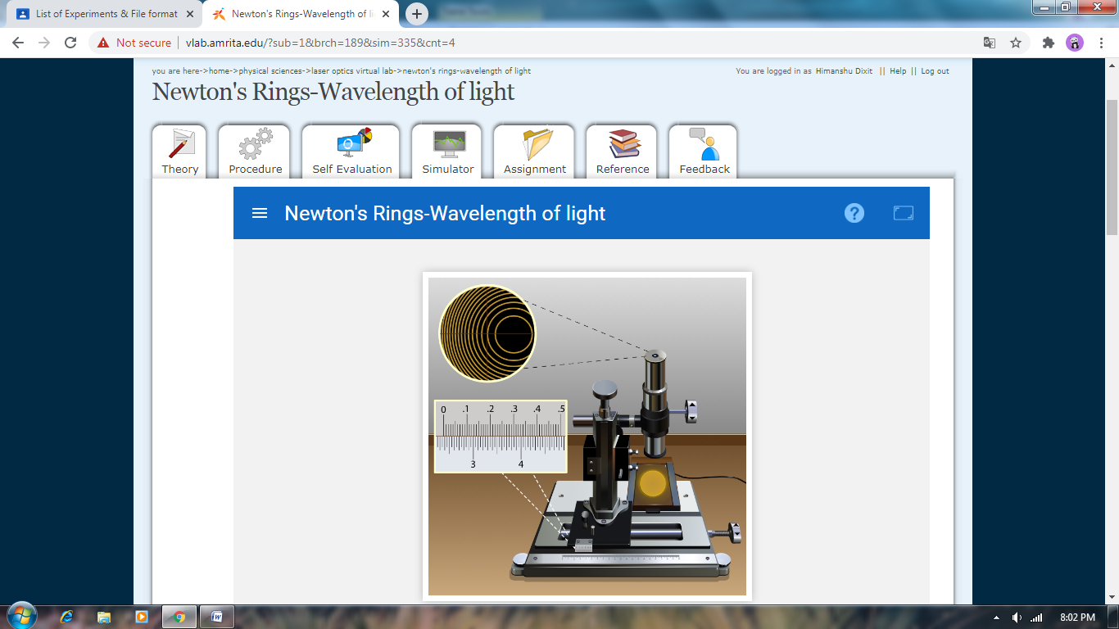

*For water:*

